# **SailPoint IIQ 8.4p1 Patching Document**

1. Copy the identity patch -8.4p1 jar to the identityiq location.

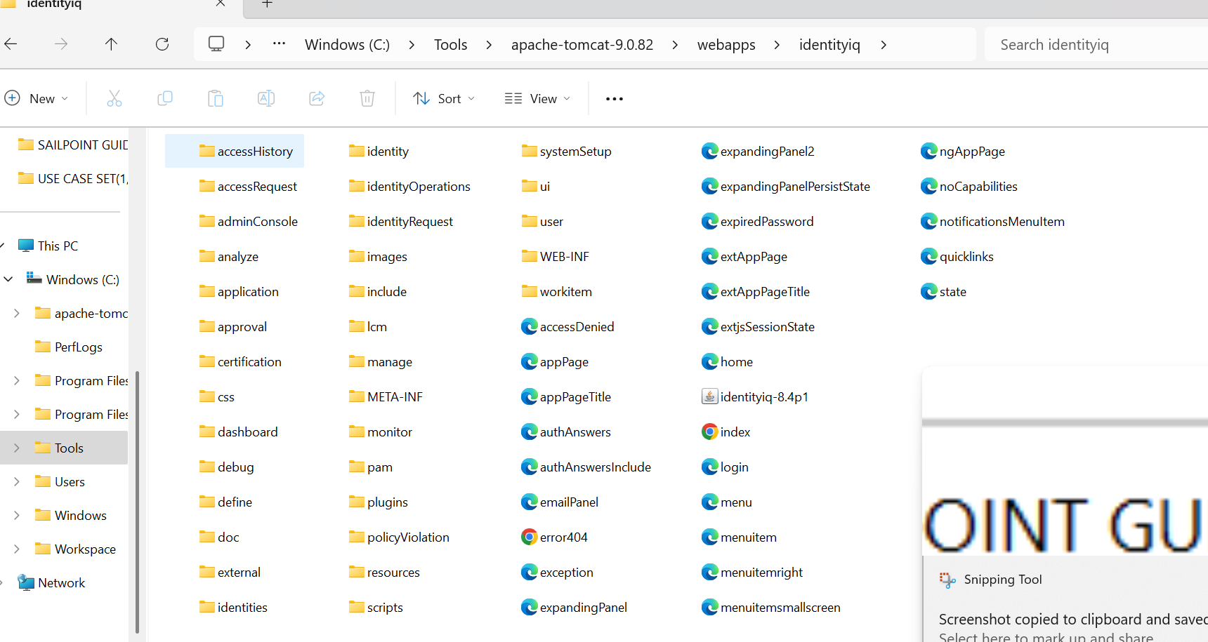

1. Run jar -xvf identity-8.4p1.jar command to extract the jar.

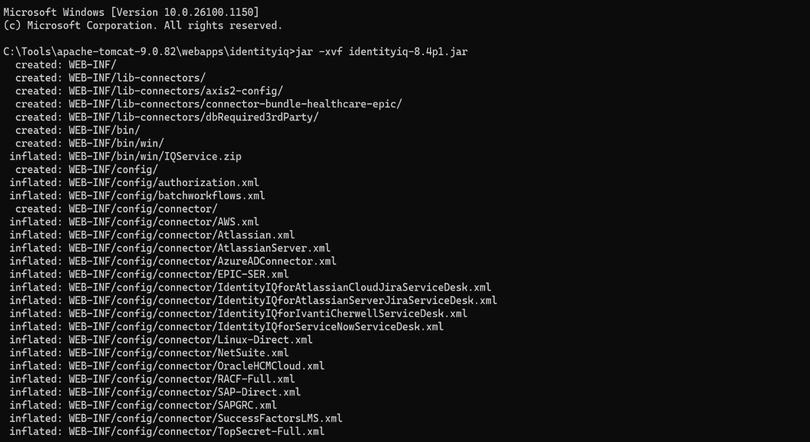

1. Run the DDL “upgrade_identityiq_tables-8.4p1” which is present in this location “Tomcat 9.0\webapps\identityiq\WEB-INF\database”.

>go to web-inf/database

>login to mysql

>run the command:

Source upgrade_identityiq_tables_8.4p1.mysql

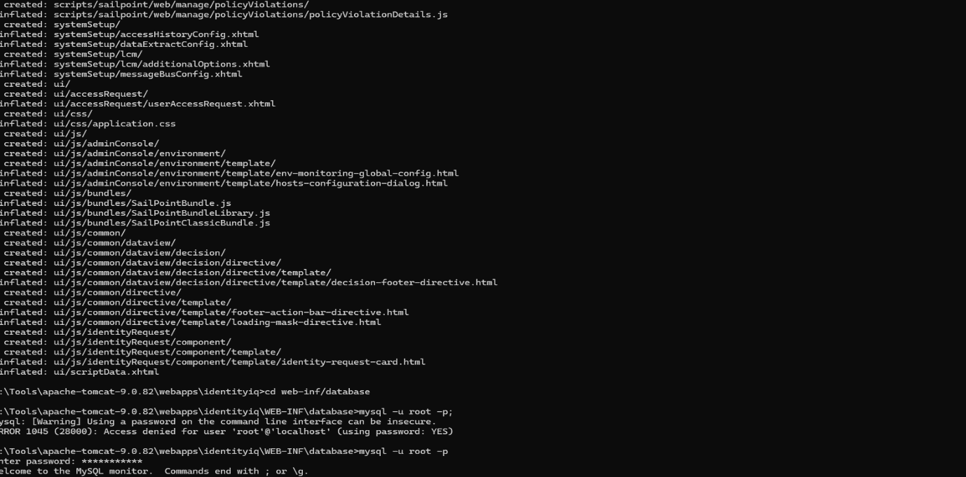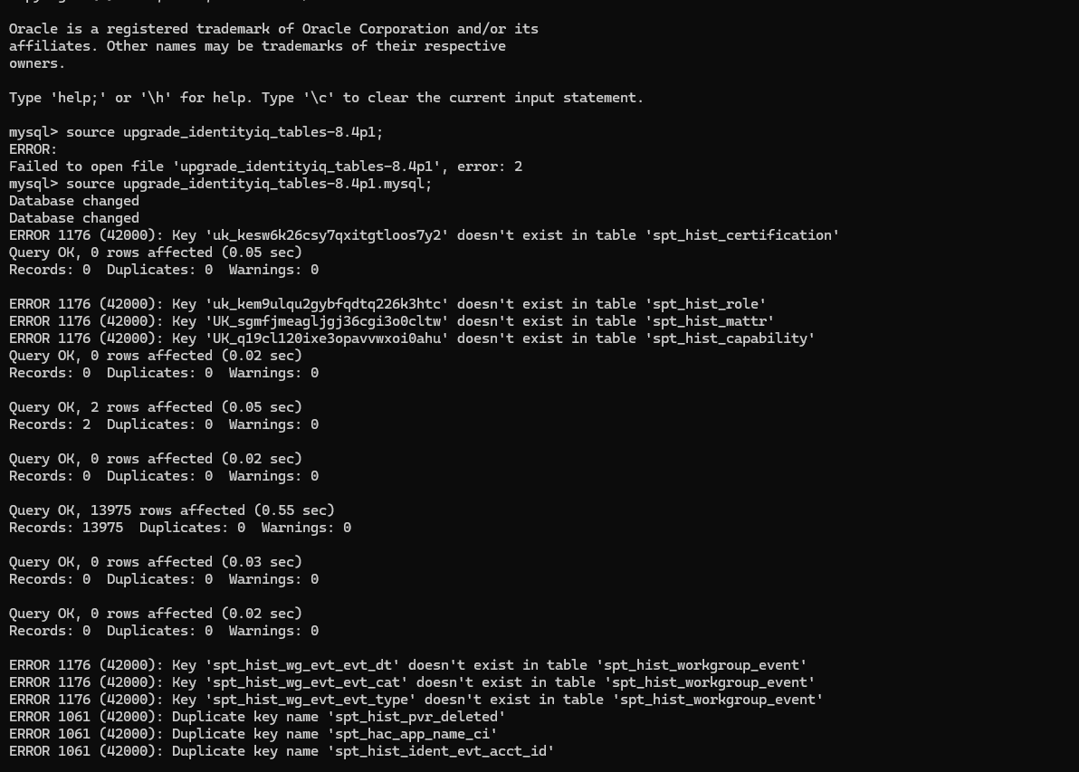

>Check the two tables

Identityiq-àspt_database_version

Identityiqah-àspt_hist_database_version

The schema version will be changed

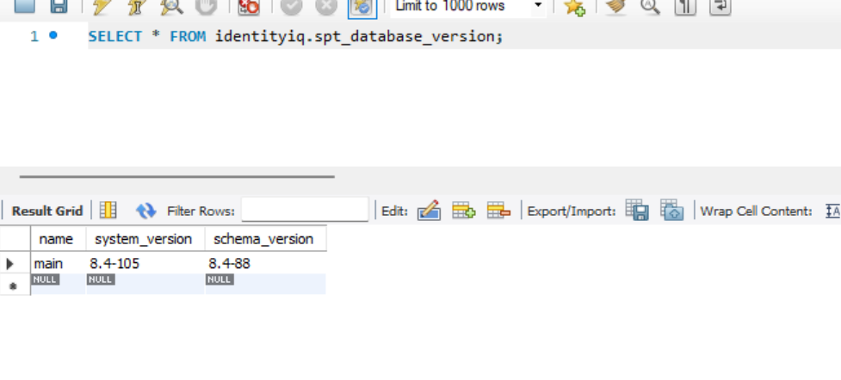

4.Apply the patch

>go to web-inf/bin path

>run the command:

iiq patch 8.4p1

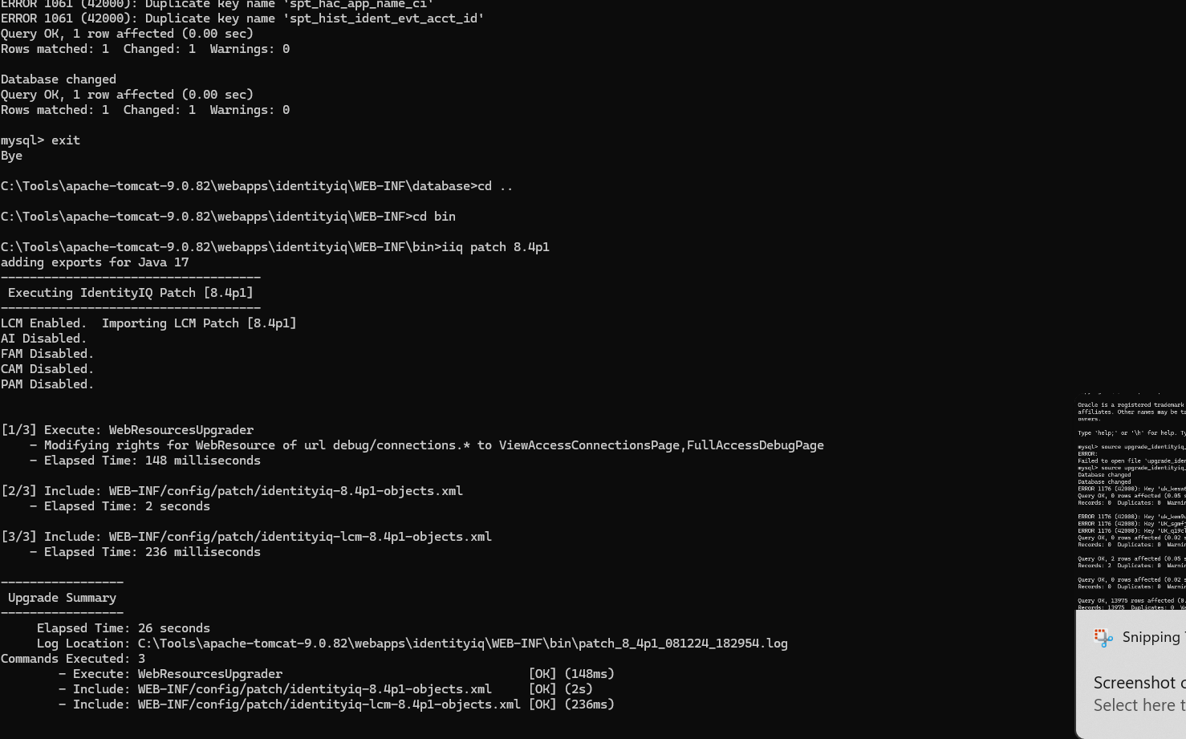

5.Start the tomcat and go to debug page

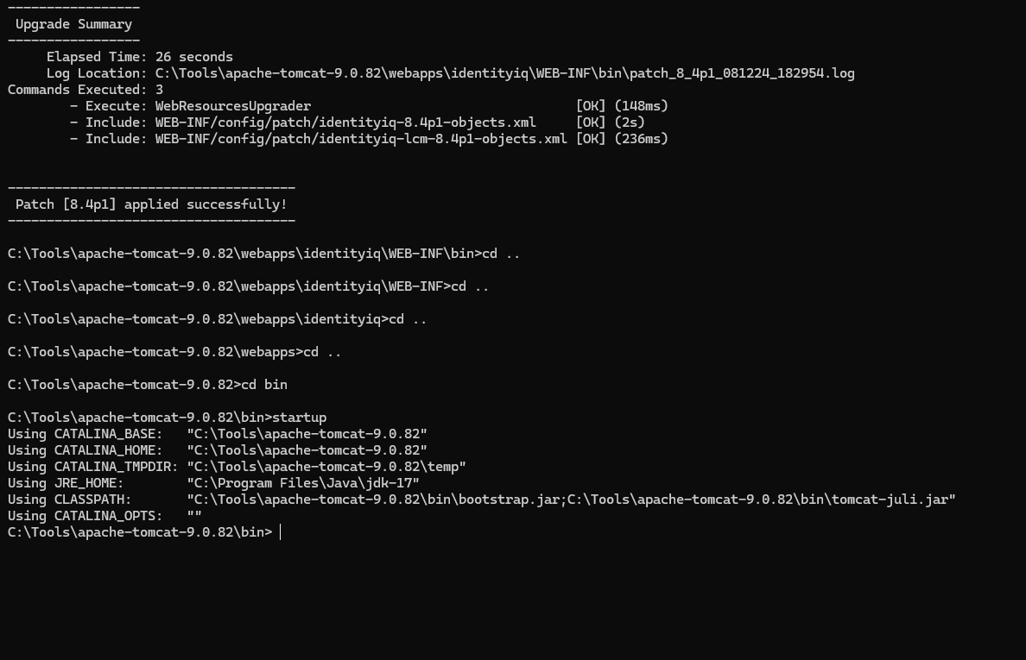

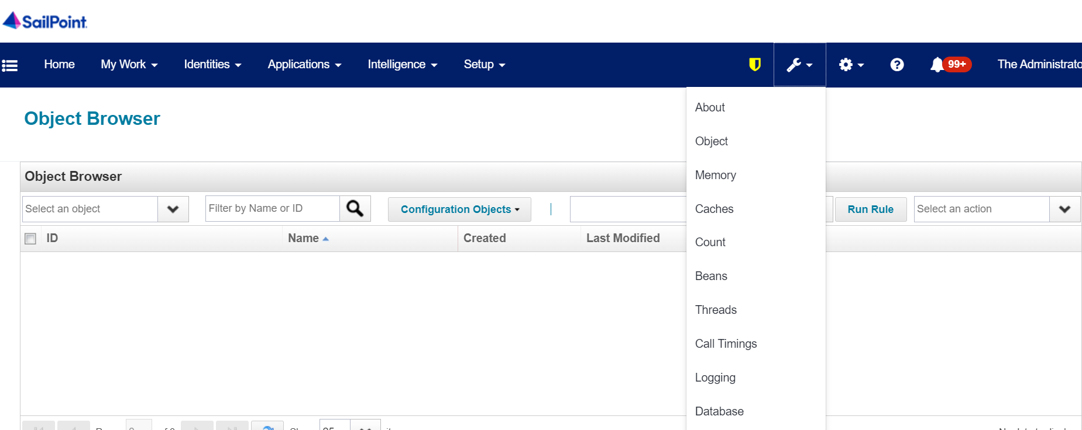

**To Know Whats New in 8.4p1 refer following link:**

<https://community.sailpoint.com/t5/IdentityIQ-Server-Software/IdentityIQ-8-4p1/ta-p/250649>